**Inventory Module**

Class diagram of Inventory Module is created by using four classes. These classes are:

1. **Product**
2. **Supplier**
3. **Purchase**
4. **Purchase Details**

**Class diagram of Inventory module is given as:**

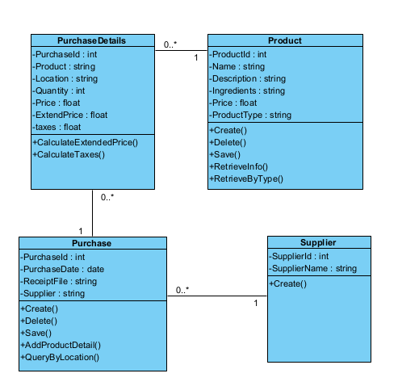

**Figure: Class Diagram**

**Description:**

This class diagram explains a representation of an inventory module for managing products, suppliers, purchases, and purchase details. Key elements of this diagram are:

**Product**

**Attributes:**

ProductID: A unique identifier for the product.

Name: The name of the product.

Description: A description of the product.

Ingredients: The ingredients of the product.

Price: The price of the product.

ProductType: The Type of the product.

**Operations:**

Create (): Creates a new product.

Delete (): Deletes a product.

Save (): Saves a product in the system.

RetrieveInfo (): Retrieves information about a product.

RetrieveByType (): Retrieves a list of products by their type.

**Supplier**

**Attributes:**

SupplierId: The Unique identifier of the supplier.

SupplierName: The name of the supplier.

**Operations:**

Create (): Creates a new product.

**Purchase**

**Attributes:**

PurchaseId: The Unique identifier of the Purchase.

PurchaseDate: The date of the purchase.

ReceiptFile: A file representing the receipt for the purchase.

Supplier: The supplier associated with the purchase.

**Operations**

Create (): Creates a new purchase.

Delete (): Deletes a purchase.

Save (): Saves a purchase in the system.

AddProductDetail(): Adds details of products purchased in this transaction.

QueryByLocation(): Retrieves purchases based on a location.

**Purchase Details**

**Attributes:**

PurchaseId: The Unique identifier of the Purchase and a foreign key.

Product:

Location:

Quantity:

Price:

ExtendPrice:

Taxes:

**Operations**

CalculateExtendedPrice(): Calculates the extended price based on quantity and unit price.

CalculateTaxes(): Calculates taxes for this purchase detail.

**Associations:**

Product to PurchaseDetail (1 to many).

Supplier to Purchase (1 to many).

Purchase to PurchaseDetail (1 to many).

This class diagram represents the core entities and their relationships in inventory module for managing products, suppliers, purchases, and purchase details. It provides a framework for getting product information, supplier information, and purchase transactions, including detailed information about the products that are purchased.

**Sequence Diagrams**

Sequence Diagrams of the Inventory Module are:

**Create Product Information**

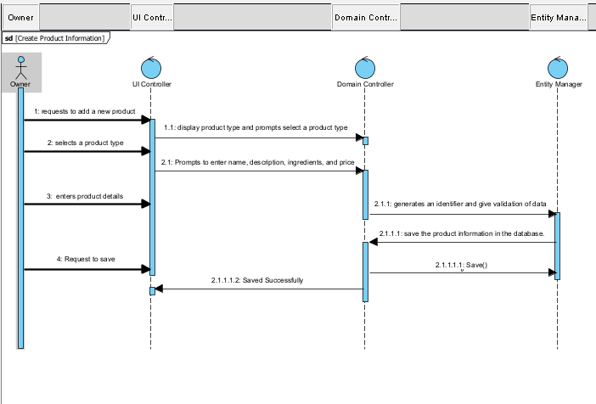

**Figure: Create Product Information**

**Brief Description**: This sequence diagram tells the interactions between the Owner, UI controller, Domain Controller, and Entity Manager where the owner records a new product.

**Flow of Activities**:

The sequence begins with the Owner's request to add a new product. The UI controller sends a request to the Domain Controller to create a new product. The Domain Controller displays a list of product types and prompts the Owner to select a product type. The Owner selects a product type from the list. The Domain Controller prompts the Owner to enter product details, including the product name, ingredients, description, and price. The Owner enters the necessary product details. The Domain Controller generates a unique identifier for the product. The Domain Controller validates the entered data to ensure it's valid. The Domain Controller displays the product with the generated identifier. The Domain Controller prompts the Owner to save the product. The Owner requests to save the product. The UI controller sends a request to the Entity Manager to save the product information in the database. The Entity Manager interacts with the database to store the product information. The product information is saved to the database successfully

**Query Products by Product Type**

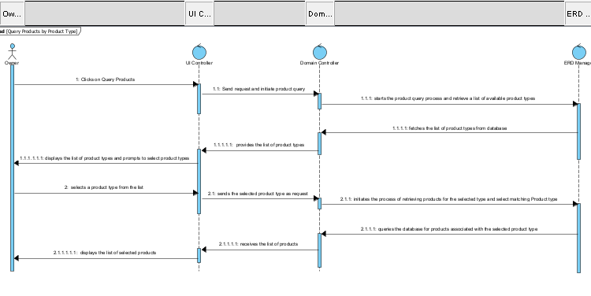

**Figure: Query Products by Product Type**

**Brief Description:** This sequence diagram tells the interactions between the Owner, UI controller, Domain Controller, and Entity Manager where the owner queries products based on product type.

**Flow of Activities**:

Owner requests to query products. The UI controller sends a request to the Domain Controller to initiate the product query process. The Domain Controller displays a list of available product types to the Owner and prompts them to select one. The Owner selects a product type. The Domain Controller sends a request to the Entity Manager to retrieve a list of products. The Entity Manager interacts with the database to retrieve the list of products. The Entity Manager returns the list of products to the Domain Controller. The Domain Controller displays the list of products. The product information is provided to the Owner as a result of the query. The sequence ends, and the Owner has access to the product information for the selected product type.

**Create Purchase**

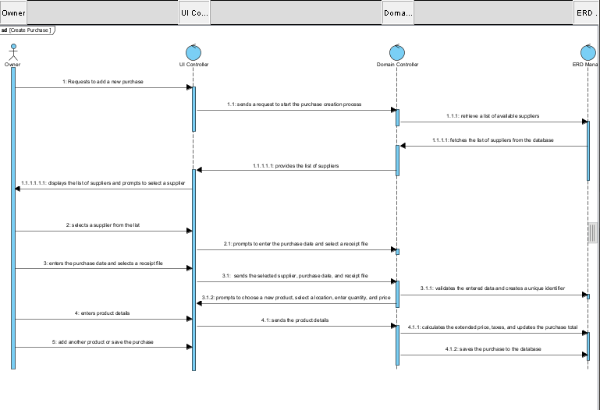

**Figure: Create Purchase**

**Brief Description:** This sequence diagram tells the interactions between the Owner, UI controller, Domain Controller, and Entity Manager where the owner records a new purchase.

**Flow of Activities**:

Requests to add a new purchase. The UI controller initiate the purchase creation process. The Domain Controller displays a list of suppliers to the Owner and prompts them to select one. The Owner selects a supplier from the list. The Domain Controller prompts the Owner to enter the purchase date and select a location to store the receipt file. The Owner enters the purchase date and selects the location for the receipt file. The Domain Controller verifies that a supplier was selected. The Domain Controller generates a unique identifier. The Domain Controller displays the purchase details, including the selected supplier, date, and location for the receipt file. The Domain Controller prompts the Owner to add products to the purchase. The Owner initiates the process of adding products to the purchase and requests to save it.

**Query Purchases**

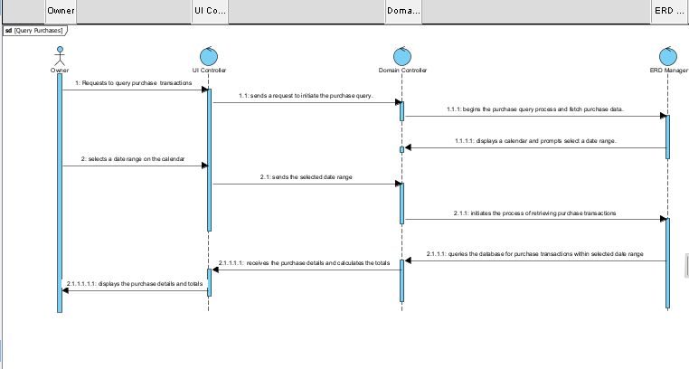

**Figure: Query Purchases**

**Brief Description**: This sequence diagram tells the interactions between the Owner, UI controller, Domain Controller, and Entity Manager where the owner queries purchase transactions by date.

**Flow of Activities**:

The sequence begins with the Owner's requests to query purchase (by date) transactions. The UI controller sends a request to the Domain Controller to initiate the purchase query process. The Domain Controller displays a calendar to the Owner and prompts them to select a date range. The Owner selects a date range on the calendar. The Domain Controller sends a request to the Entity Manager to retrieve purchase transactions within the specified date range. The Entity Manager interacts with the database to retrieve purchase transactions within the specified date range. The Entity Manager calculates the purchase totals and retrieves the purchase details. The Entity Manager returns the list of purchase transactions along with totals to the Domain Controller. The Domain Controller displays the list of purchase transactions. The purchase transaction information is provided to the Owner.